**Ubuntu Server Installation**

* To start, the installation process is very generic with basic user preferences such as language, keyboard style, etc. You will be prompted to create a new user and password for the server, as well as a password for the root user. Think of the root user as the admin for the server. Choose your preferred user settings and passwords and continue to the next steps.

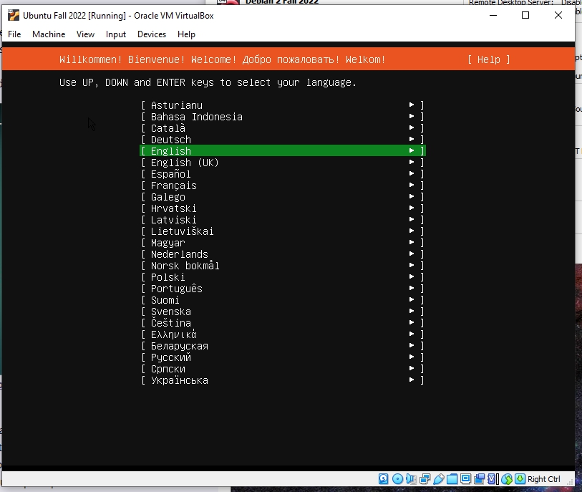

* Next, choose the base for the installation, the two options are Ubuntu Server and the minimized version. For this, we will be using the standard Ubuntu Server.

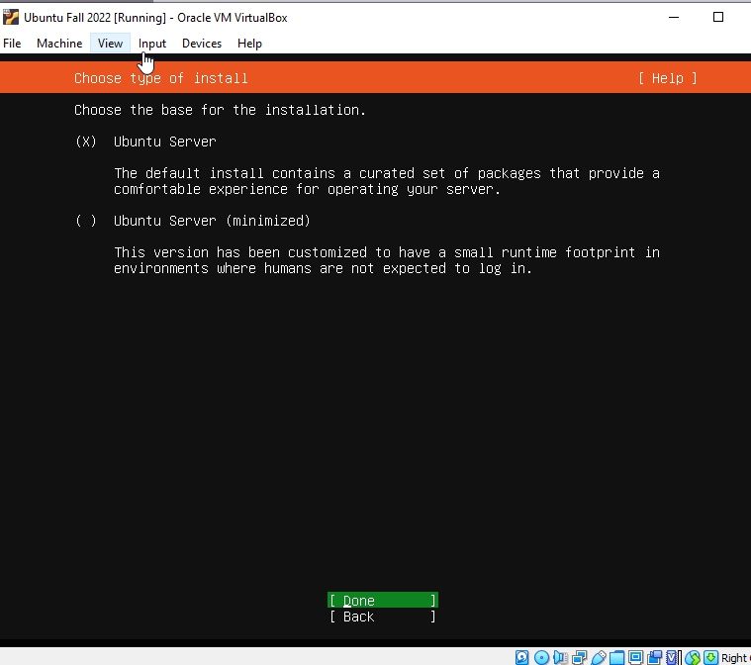

* Unless the user is doing something more specific and intricate, the default settings will suit those who are new to virtualization. Below is the option to configure the network. Choose which network adapter you would like to use and move on to the next step.

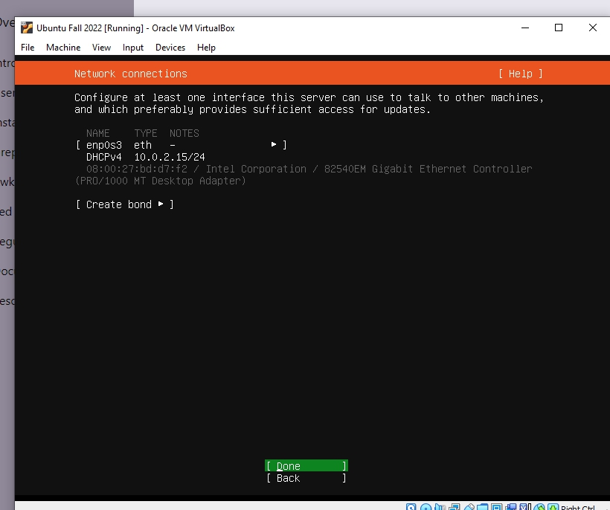

* Choose to install OpenSSH server, this is useful for sharing files and accessing the server remotely.

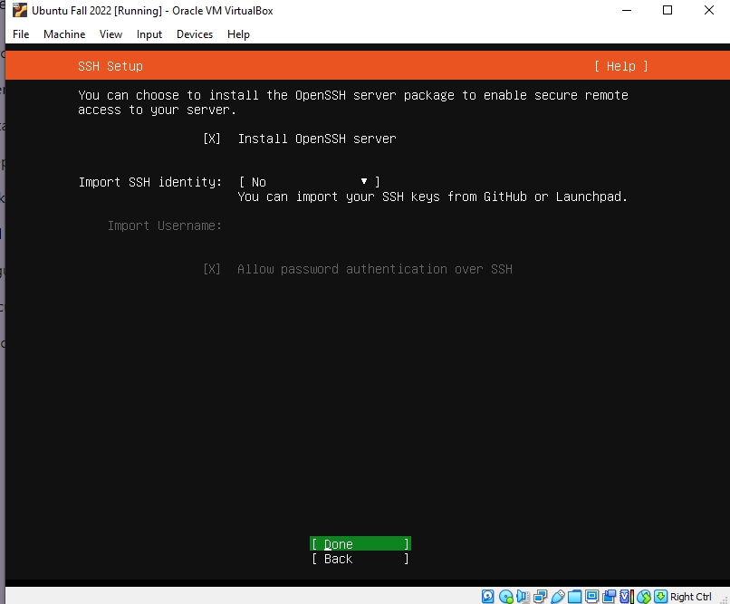

* You will then be prompted to select any additional features you would like to add to the server. I did not select any simply because they are unnecessary for this project and can be installed later. Press Enter to confirm and start the installation.

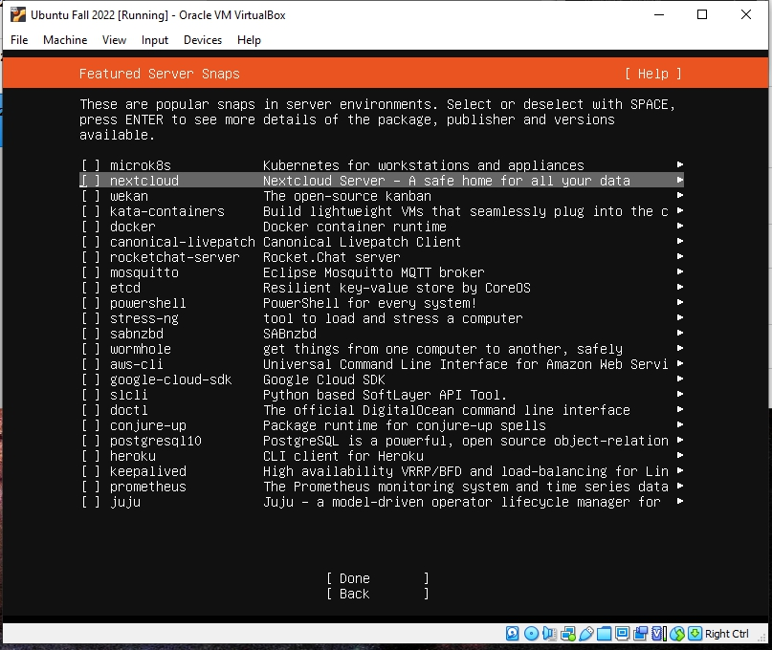

* The screen will look like this once the process has started. When finished select the option to reboot.

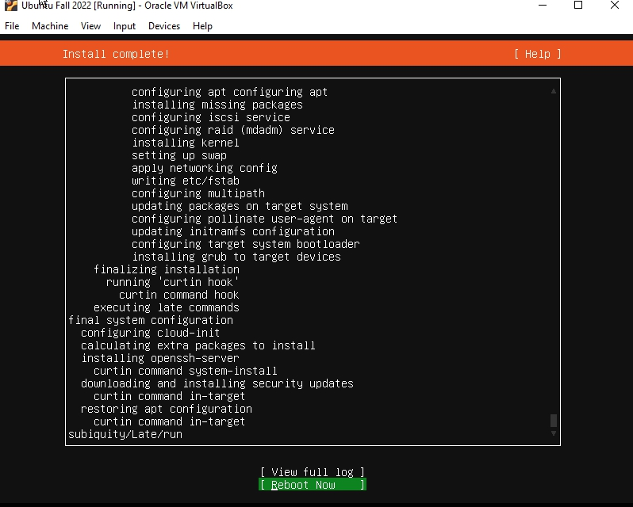

* After the reboot, log in with the user account you created and proceed to install SmarTTY. Type in “sudo apt-get install -y smarty” to install SmarTTY. You will be able to see if the installation was successful or not.

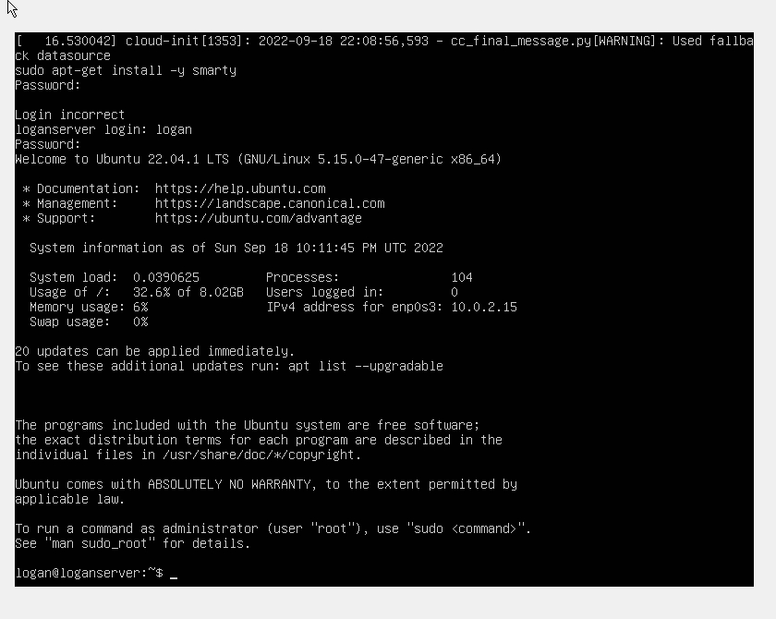

* Next, we will install the tools to check the status and configure network settings on the server. Use command “sudo apt install net-tools”. Ensure the installation is successful.

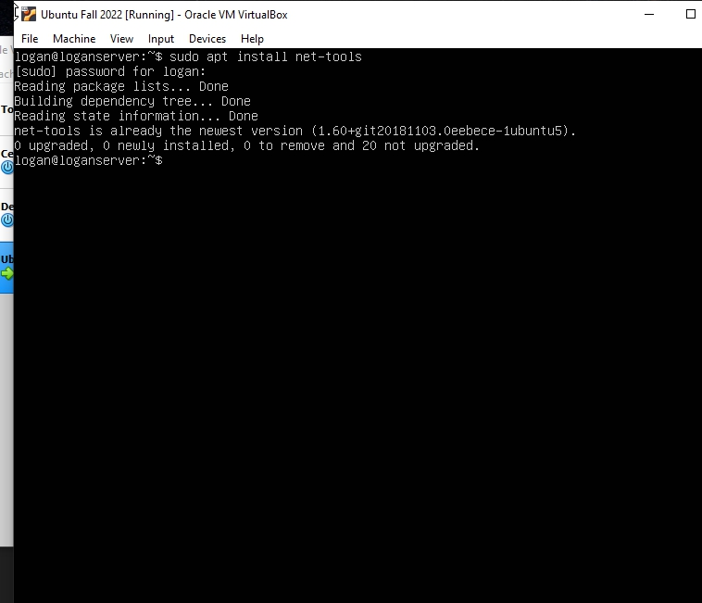

* We can now run a network configuration command on the server. Run the command “ifconfig”, this will show the configuration settings for the current network connection. Confirm the connection is enabled, this is the last step of the basic installation process.

